Halogen Free* Epoxy Adhesives
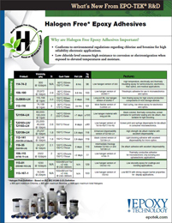 | Epoxy Technology offers New Halogen Free* Epoxy Adhesives. These products conform to environmental regulations and provide corrosion or electromigration resistance for high reliability electronic applications.

