**Room Temperature Curing ECAs**

[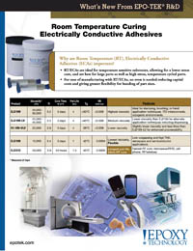](https://www.epotek.com/site/files/brochures/pdfs/RT_ECA_01_09_lowres.pdf)

Epoxy Technology, Inc. (EPO-TEK®) offers an expanded line of Room Temperature Curing Electrically Conductive Adhesives (ECAs).  These ECAs are ideal for temperature sensitive substrates, allowing for a lower stress cure, best for large parts as well as high stress, temperature cycled parts. These epoxies require no oven curing; reducing capital costs and giving greater flexibility for bonding various part sizes.

EPO-TEK® EJ2189, EJ2189-LV, EJ2108, and EJ2312 are excellent options for applications that require a Room Temperature ECA.